**Online Game**

Description

A 2D single player game where the player can move up to avoid obstacles when playing the game, pause and restart the game. The user has a nick that can be changed anytime, the sound settings can be changed as well as the character color. The high score is saved to a game wide leaderboard and is updated once a new record is made by the player and saved to each account.

The admin should be able to test the game, as well as all the features included to all regular players, but they can also add new users according to the access preferences and ban users as well.

Each player’s points should be saved according to the unique nick of each player. Game wide high score leaderboard.

Scope

|  |  |  |
| --- | --- | --- |
| Who | Why | What |
| Player | Access and play the game. | * Create an account. * Sign in. * Play the game. * Pause the game. * Select character features. * Change settings. * Access the leaderboard. * Return to the home page. |
| Admin | Access and play the game, change user access, create new users and ban users. | * Sign in. * Play the game. * Pause the game. * Select character features. * Change settings. * Access the leaderboard. * Return to the home page. * Create new users. * Ban users. |

Backlog

|  |  |  |  |
| --- | --- | --- | --- |
| User Stories ID | Description | User Stories Points | Priority |
| GS1 | As a user create an account | 8 | HIGH |
| GS2 | As a user login to the game | 8 | HIGH |
| GS3 | As a user customize the character color | 5 | LOW |
| GS4 | As a user change the nick | 3 | LOW |
| GS5 | As a user play the game | 5 | HIGH |
| GS6 | As a user pause the game | 3 | MEDIUM |
| GS7 | As a user retry the game after game over | 5 | MEDIUM |
| GS8 | As a user access the leaderboard | 1 | LOW |
| GS9 | As a user return to the home page | 1 | MEDIUM |
| GS11 | As a user confirm the changes in a page | 3 | HIGH |
| AS1 | As admin create new users for testing purposes | 5 | HIGH |
| AS2 | As admin ban users from the game | 1 | HIGH |
| AS4 | As admin return to the home page | 1 | MEDIUM |
| AS3 | As admin access the leaderboard | 1 | LOW |
| AS5 | As admin confirm changes in a page | 3 | HIGH |
| AS6 | As admin test the game | 8 | HIGH |
| Total: 61 points | | | |

|  |  |  |  |
| --- | --- | --- | --- |
| Iterations | USID | Points/Iteration | Deadline |
| Iteration 1 | GS1 + GS2 + GS5 | 21 | March 28th |
| Iteration 2 | AS6 + AS1 + AS2 + GS11 + AS5 + GS8 | 21 | April 11th |
| Iteration 3 | GS3 + GS4 + GS6 + GS7 + GS9 + AS3 + AS4 + AS7 | 19 | April 28th |

Non-Functional Requirements

* Performance – it responds quickly to the users’ commands.
* Availability – the online game is always available, except when there’s an update to be made.
* Usability – the system is easy to use with clear buttons and what is in each page.

Figure 1 - Start Page

Figure 2 - Sign Up Page

Figure 3 - Sign In Page

Figure 4 - Player Home Page

Figure 5 - Admin Home Page

Figure 6 - Play Page

Figure 7 - Pause Page

Figure 8 - Leaderboard Page

Figure 9 - Customize Page

Figure 10 - Settings Page

Figure 11 - User Management Page

Figure 12 - Create a new user

Figure 13 - Ban a User

Figure 14 - Use Case Diagram

Figure 15 - Player Activity Diagram

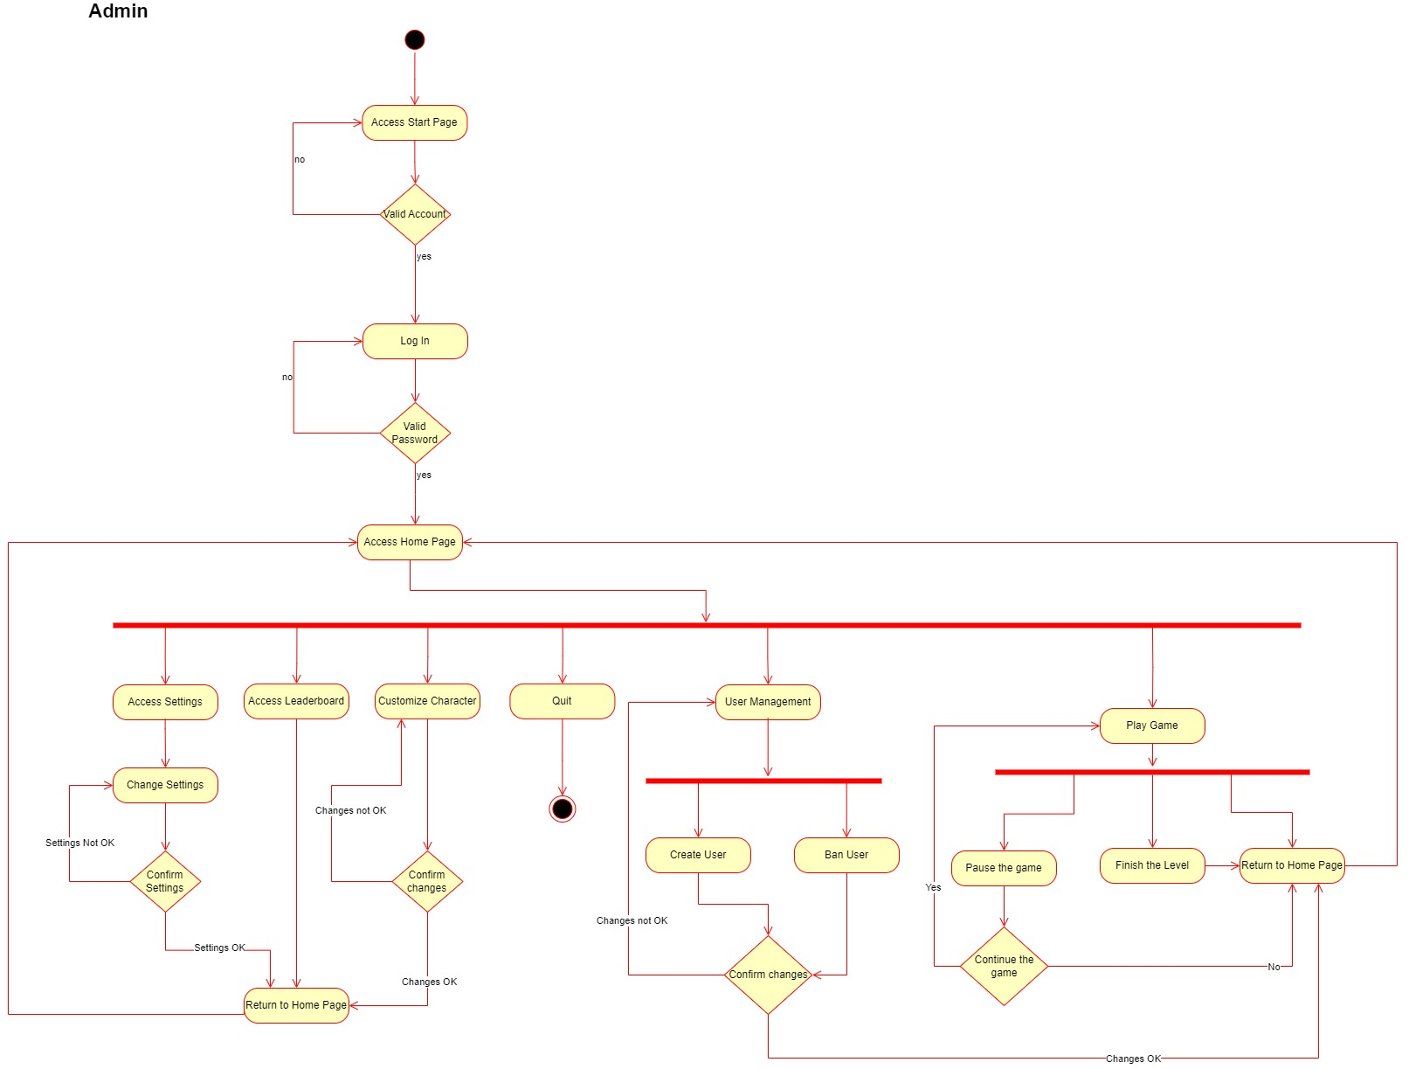

Figure 16 - Admin Activity Diagram

Figure 17 - Player Sequence Diagram

Figure 18 - Admin Sequence Diagram

Figure 19 - Class Diagram